***FMA***

***WEB AUTHORING***

***-***

***EMBLEM COLLECTIBLE BOOKS***

Name: Manuel Piatesi

Due date: 02-08-16

Module: Advanced Web Authoring

Tutor: Marcel Krajca

**TABLE OF CONTENTS**

WEBSITE URL……………………………………………………………………………………………………………3

SEMANTIC APPROPRIATENESS…………………………………………………………………………………3

PROBLEMS ENCOUNTERED………………………………………….………………………………………….3

**Website url**

<http://titan.dcs.bbk.ac.uk/~mpiate01/wafma/index.html>

DA SCRIVERE LA PARTE INIZIALE – CON PUNTI DEBOLI E DI FORZA

**Browser compatibility**

The website has been built following common technics to guarantee his full functionality regardless the browser that user might use.

**HTML5 Shim**

Html5 has been used to build the skeleton of the webpage, but not all his features are fully supported by older browser. In the website tags as “header”, ”main”, “footer”, “nav”, “section”, “article”, “aside”, have been used but they are treated as unknown elements for a browser as IE6, hence they cannot be properly styled unless a JavaScript file is used. Therefore, to overcome this issue, a conditional comment has been used, in the “head” tag, to target IE versions lower than 9 and apply the “HTML5 shiv” script to allow html5 tags to be styled with CSS.

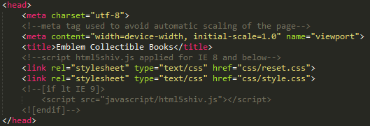

**Fig. 1. Conditional comment for IE < 9.**

The “HTML5 shiv” has been applied only to IE < 9 and not as default to improve the speed of rendering the webpages. The CSS files are loaded only after the script to avoid the “flashing” issue of changing styling of the page’s elements while loading the webpage that I firstly had while testing the page with IE11.

The script alone is not enough for the website to display all the new html5 tags. The reset CSS file has to include a declaration block targeting the new HTML5, otherwise all versions of IE won’t be able to properly display them. I have encountered this issue testing the website with IE11 and I managed to overcome the “bug” visiting the website <http://stackoverflow.com>.

**CSS Reset**

Every browser applies default styles to all HTML elements, therefore to avoid cross-browser differences as much as possible, a CSS reset file has been created and loaded before the “custom” CSS file. VEDERE SE AGGIUNGERE ALTRE COSE

**Embedding**

The website has been built embedding a font and a video file, but older browsers might not support all format types. Therefore for a maximum browser support, I have included different formats for font and video for modern and old browsers.

The five font formats are:

* format("embedded-opentype") for IE6-IE8;
* format("woff") for modern Browsers;
* format("truetype") for Safari, Android, iOS;
* format("svg") for old iOS;
* format(“eot") for IE9.

The four video formats are:

* type="video/webm" for Firefox, Chrome, Opera;
* type="video/mp4" for IE, Safari and some versions of Chrome/Firefox;
* type="video/ogg"for old versions of Firefox;
* downloadable video.

I have encountered in an issue on applying the custom font. Earlier I have wrote the declaration CSS code for embedding the font in a different order and it was not working properly. I have resolved the issue as it follows:

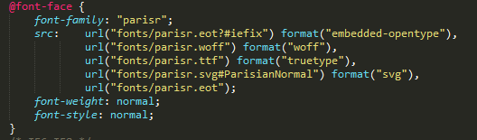

**Fig. 2. Font embedding.**

**Cross-compatibility weakness**

**Media Queries**

A weakness of the website’ styling might be found on the media queries used to display the pages. Media features are not supported in the old version of IE therefore the page cannot be display properly accordingly to different device widths. During the testing phase “screen/9” has been add to the media queries and it seemed to have improved the website’s view with IE8 and IE7, but the layout still breaks with IE6. Furthermore, the main navigation bar layout breaks by using IE8.

**Box/Text shadow – Border radius**

CSS features as box/text shadow and border radius are supported only with IE version 9 and more, therefore if an older IE would be used, the company logo and other elements of the website will not be displayed properly and the page layout would change. A way to overcome this issue, it would be to use images instead of those properties.

**Placeholder**

The placeholder properties has been used to increase accessibility and “webkits” have been used to guarantee cross-compatibility, but unfortunately it could not be tested properly in older IE versions.

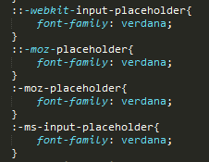

**Fig. 3. Placeholder.**

**Accessibility**

The website has been built to be accessible to people with a diverse abilities and technology accesses.

An online tool, wave.webaim.org, has been use to test the accessibility of the website. It highlights strengths and weaknesses based on the best technics recommended by W3C.

**Technical standards**

Technical standards have been used to optimise the site accessibility for people using screen readers and keyboards/joysticks.

For screen readers, ARIA landmarks roles have been added to semantic mark-ups to enable user to navigate to specific areas of the page and to describe individual elements and their relationship.



**Fig.4 Aria roles.**

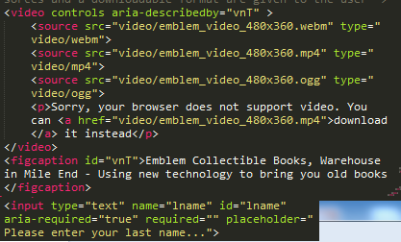

**Fig.5 Aria landmark for describe elements.**

The online tool has been useful for detecting “orphan” sections with a landmark role missing and fix it. Furthermore, the attribute scope has been added to help users in “reading” tables.

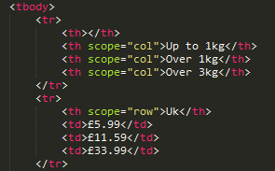

**Fig.6 Scope attribute for tables.**

To display delivery charges has been used a description list instead of another type of list with the same goal of improving readability.

The website contains also “skip links” and “back to top links” to improve user experience while using only keyboards or joysticks. They are used to skip straight away to the “interested” content of the page (they are only visible while “focused”).

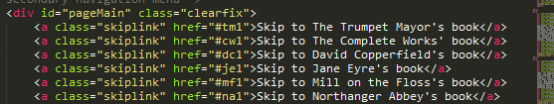

**Fig. 6 Example of skip links.**

**Design standards**

The website includes a form and it is important to help users in filling it up. Therefore the form has been built with design features to improve accessibility in terms of showing required fields and errors and helps on filling the field up (placeholder property). A different colour has been used when a required field has been selected and the aria property “required” has been added for screen reader users.

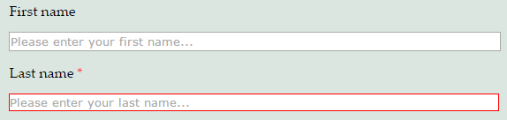

**Fig.7 Form enanchement.**



**Fig.8 Example of a required field and placeholder property**

Media queries have been used to guarantee the same experience regardless the device used to display the website. They have been choose by studying all the breaking point of the design and changing the CSS properties accordingly. A semantic mark-up and CSS properties help to keep the layout fluid while resizing the page.

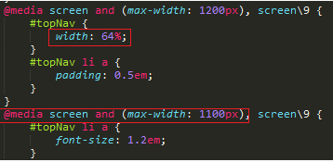

**Fig.9 Example of CSS properties**

**Weaknesses**

The online tool highlights few issues regarding readability and layout display.

Generally, the choice of colours is acceptable, but there could be an issue for some user on reading a text with a “gold” colour over a “light blue” background. To improve readability a big font-size has been choose.

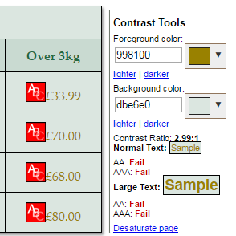

**Fig. 10 Colour tool.**

Another issue regards the form “resizing-capability”. Unfortunately, the form does not resize properly while the total device’s width is less than 300px even if all the coding standards have been applied. Furthermore there is a slight change of display of the required fields while “on focus”. This issue can be considered either a quality or bug of the design. It might be considered a quality because it helps the user to focus his attention on it.

**References**

<https://css-tricks.com.>

<http://stackoverflow.com>.

http://wave.webaim.org.